**Workforce Administration Solution**

**1.Project Overview**

The **Workforce Administration Solution** is a robust software platform developed to optimize and automate key workforce management processes within an organization. By centralizing and streamlining the management of employee data, project assignments, performance tracking, and asset allocation, this solution enhances operational efficiency. It provides real-time insights into employee workload, project progress, and asset usage, ensuring better resource management and decision-making. Additionally, the platform fosters collaboration across teams, offering intuitive user interfaces, customizable dashboards, and detailed reporting capabilities. This comprehensive solution empowers organizations to effectively manage their workforce, improve accountability, and drive performance, ultimately leading to greater productivity and a more agile workforce.

### 2. ****Objective of the Workforce Administration Solution Project****

The objective of the **Workforce Administration Solution** is to develop a centralized platform that streamlines the management of employee data, project assignments, and asset allocation within an organization. This solution aims to improve operational efficiency by automating workflows, providing real-time tracking and insights, enhancing collaboration, and ensuring data security. It focuses on optimizing resource utilization, monitoring employee performance, and delivering actionable reporting for data-driven decision-making, ultimately driving productivity and organizational growth.

### ****Business Goal****

The primary business goal of the **Workforce Administration Solution** is to enhance organizational efficiency by centralizing and automating workforce management processes. This will help businesses optimize resource allocation, reduce operational costs, improve accountability, and make data-driven decisions

### ****Specific Goals****

1. **Centralize Workforce Data**: Consolidate employee information, project assignments, and asset management into one unified system for better visibility and control.
2. **Improve Resource Allocation**: Ensure efficient project assignments and asset utilization by providing real-time tracking and insights on employee workload and resource distribution.
3. **Enhance Employee Performance Monitoring**: Track employee performance across projects to identify high performers, address challenges, and support professional development.

**3.Custom Object for Workforce**

**Employee Object**

* **Purpose**: Track employee details, activities, and performance.
* **Key Fields**: Employee ID (Auto Number), name, job title, department, assigned projects, and performance metrics.

**Project Object**

* **Purpose**: Store information about ongoing and completed projects.
* **Key Fields**: Project ID (Auto Number), project name, start date, end date, status, budget, and project manager.

**ProjectTask Object**

* **Purpose**: Manage tasks within projects, including deadlines and assigned employees.
* **Key Fields**: Task Name (Text), task description, due date, priority, completion status, and assigned employee.

**Asset Object**

* **Purpose**: Track organizational assets, their condition, and their usage in projects.
* **Key Fields**: Asset ID, type, location, purchase date, assigned employee, and condition.

**Asset Service Object**

* **Purpose**: Manage the service and maintenance of assets.
* **Key Fields**: Service Type, service date, service status, next service due date, and associated asset.

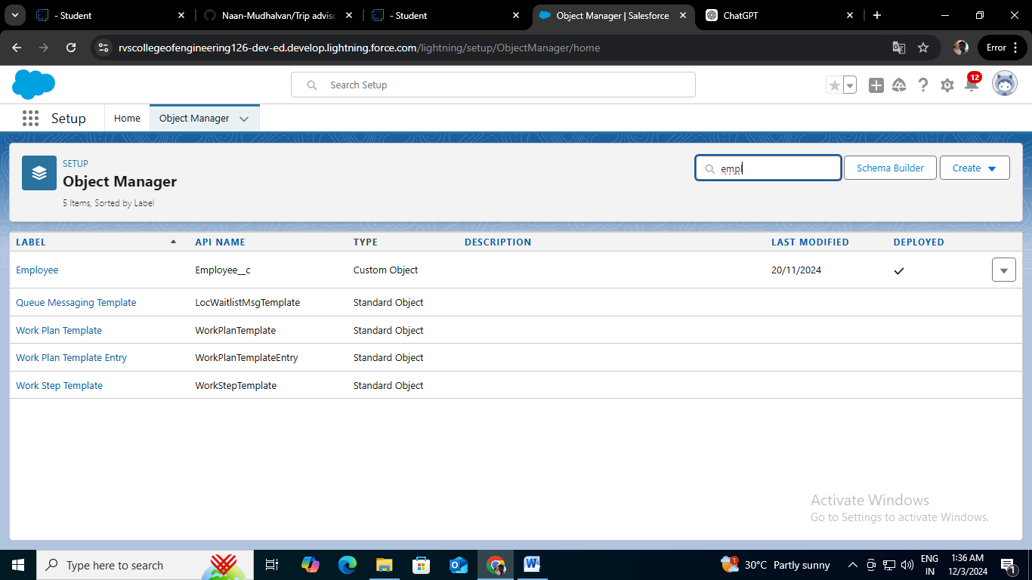

**4.Workforce Administrator Solution Lightning App**

**Purpose of the App:**

* Centralize access to workforce and project-related data.
* Provide intuitive navigation for managing employees, tasks, and resources.
* Enable tracking and reporting through integrated dashboards and reports.

**Key Work Done:**

1. **App Details and Branding Configured:**

* App Name: **Workforce Administrator Solution**
* Description: A meaningful description provided to reflect the app's purpose.

1. **Default App Options and Utility Items Set:**

* Kept configurations simple and user-friendly by retaining default settings.

1. **Navigation Items Added:**

* Integrated key objects into the app for streamlined access:- Employees, Projects, ProjectTask, Assets, Asset Services, Reports, and Dashboards.

1. **User Profiles Assigned:**

* Granted app access to the System Administrator profile to ensure management-level control.

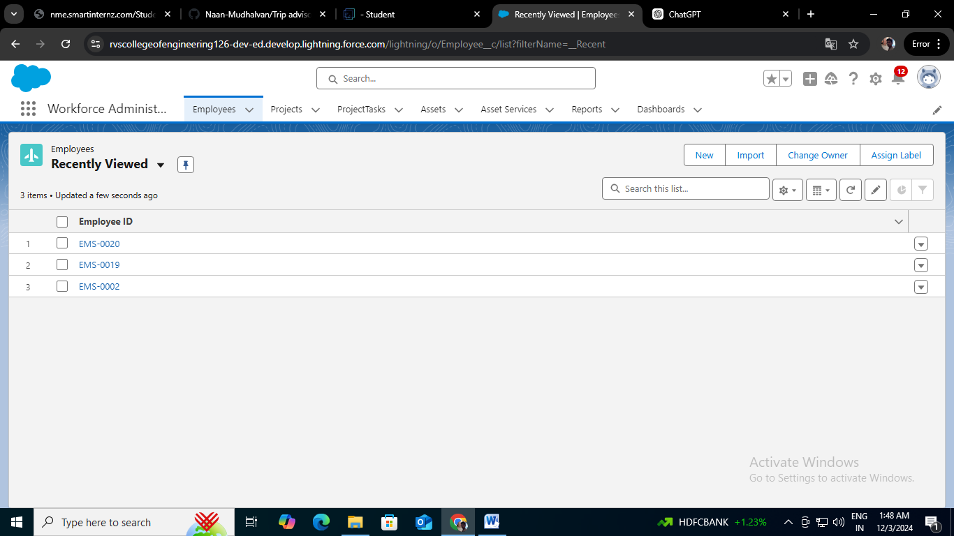

**5.Field & Relationships**

In workforce administration, **fields** play a crucial role in organizing and managing employee data. These fields represent the data stored in the columns of a relational database, simplifying the processes of searching, editing, and deleting records. Salesforce offers two types of fields to meet varying data management needs: **Standard Fields** and **Custom Fields**

### ****Types of Fields in Workforce Administration****

#### ****1. Standard Fields****

Standard fields are predefined in Salesforce and serve essential administrative tasks. These fields are consistent across all Salesforce objects and cannot be deleted unless they are non-required. In workforce administration, standard fields ensure key employee information is captured and maintained effectively. Examples of common standard fields include:

* **Created By**: Tracks the administrator or user who created the employee record.
* **Owner**: Indicates who is responsible for or owns the employee record.
* **Last Modified**: Logs the date and user who last updated the record.
* **Object-Specific Fields**: Generated automatically when an object (e.g., Employee) is created.

Standard fields maintain the integrity of employee records and provide a uniform data structure.

#### ****2. Custom Fields****

Custom fields offer flexibility for workforce administration by enabling organizations to tailor Salesforce to their unique HR needs. These fields can be added, edited, or removed as required, allowing companies to capture data that may not be included in the default setup. Examples of how custom fields can enhance workforce administration include: .